ATIVIDADE 2.1

Diagrama de blocos para os itens a,b,c e d: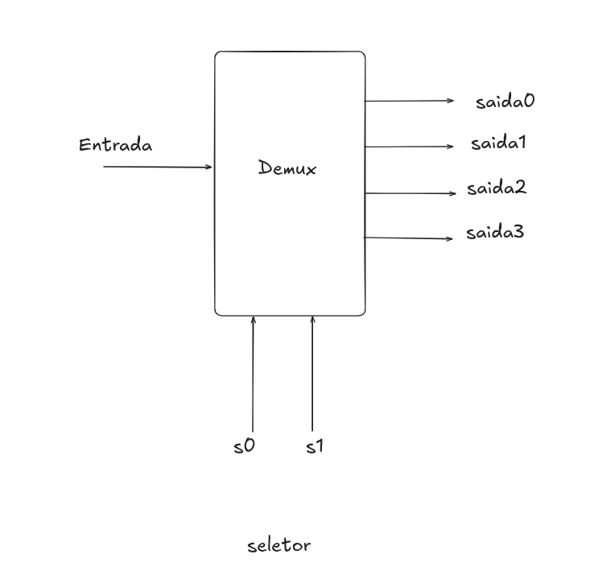
Tabela verdade para os itens a,b,c e d:

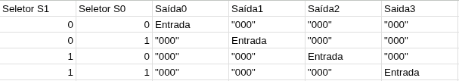

CÓDIGOS:

Código item 2.1 a:

library IEEE;
use IEEE.STD_LOGIC_1164.ALL;

entity demux_1x4 is
Port (
entrada : in STD_LOGIC_VECTOR(2 downto 0);
seletor : in STD_LOGIC_VECTOR(1 downto 0);
saida0 : out STD_LOGIC_VECTOR(2 downto 0);
saida1 : out STD_LOGIC_VECTOR(2 downto 0);
saida2 : out STD_LOGIC_VECTOR(2 downto 0);
saida3 : out STD_LOGIC_VECTOR(2 downto 0)
);
end demux_1x4;

architecture mapeamento of demux_1x4 is
begin
saida0 <= entrada when seletor = "00" else "000";
saida1 <= entrada when seletor = "01" else "000";
saida2 <= entrada when seletor = "10" else "000";
saida3 <= entrada when seletor = "11" else "000";
end mapeamento;

Código item 2.1 b:

library IEEE;
use IEEE.STD_LOGIC_1164.ALL;

entity demux_1x4 is
Port (
entrada : in STD_LOGIC_VECTOR(2 downto 0);
seletor : in STD_LOGIC_VECTOR(1 downto 0);
saida0 : out STD_LOGIC_VECTOR(2 downto 0);
saida1 : out STD_LOGIC_VECTOR(2 downto 0);
saida2 : out STD_LOGIC_VECTOR(2 downto 0);
saida3 : out STD_LOGIC_VECTOR(2 downto 0)
);
end demux_1x4;

architecture mapeamento of demux_1x4 is
begin

with seletor select
saida0 <= entrada when "00",
"000" when others;

with seletor select
saida1 <= entrada when "01",
"000" when others;

with seletor select
saida2 <= entrada when "10",
"000" when others;

with seletor select
saida3 <= entrada when "11",
"000" when others;

end mapeamento;

Código item 2.1 c:

library IEEE;
use IEEE.STD_LOGIC_1164.ALL;

entity demux_1x4 is
Port (
entrada : in STD_LOGIC_VECTOR(2 downto 0);
seletor : in STD_LOGIC_VECTOR(1 downto 0);
saida0 : out STD_LOGIC_VECTOR(2 downto 0);
saida1 : out STD_LOGIC_VECTOR(2 downto 0);
saida2 : out STD_LOGIC_VECTOR(2 downto 0);
saida3 : out STD_LOGIC_VECTOR(2 downto 0)
);
end demux_1x4;

architecture mapeamento of demux_1x4 is
begin

process(entrada, seletor)
begin

if seletor = "00" then saida0 <= entrada;
elsif seletor = "01" then saida1 <= entrada;
elsif seletor = "10" then saida2 <= entrada;
elsif seletor = "11" then saida3 <= entrada;
end if;
end process;

end mapeamento;

Código item 2.1 d:

library IEEE;
use IEEE.STD_LOGIC_1164.ALL;

entity demux_1x4 is
Port (
entrada : in STD_LOGIC_VECTOR(2 downto 0);
seletor : in STD_LOGIC_VECTOR(1 downto 0);
saida0 : out STD_LOGIC_VECTOR(2 downto 0);
saida1 : out STD_LOGIC_VECTOR(2 downto 0);
saida2 : out STD_LOGIC_VECTOR(2 downto 0);
saida3 : out STD_LOGIC_VECTOR(2 downto 0)
);
end demux_1x4;

architecture mapeamento of demux_1x4 is
begin

process(entrada, seletor)
begin

case seletor is
when "00" => saida0 <= entrada;
when "01" => saida1 <= entrada;
when "10" => saida2 <= entrada;
when "11" => saida3 <= entrada;
when others => null;
end case;
end process;

end mapeamento;

Plano de simulação usado nos items 2.1 a,b,c e d:
library IEEE;
use IEEE.STD_LOGIC_1164.ALL;

entity tb_demux_1x4 is
end tb_demux_1x4;

architecture simulacao of tb_demux_1x4 is

component demux_1x4
Port (
entrada : in STD_LOGIC_VECTOR(2 downto 0);
seletor : in STD_LOGIC_VECTOR(1 downto 0);
saida0 : out STD_LOGIC_VECTOR(2 downto 0);
saida1 : out STD_LOGIC_VECTOR(2 downto 0);
saida2 : out STD_LOGIC_VECTOR(2 downto 0);
saida3 : out STD_LOGIC_VECTOR(2 downto 0)
);
end component;

signal t_entrada : STD_LOGIC_VECTOR(2 downto 0);
signal t_seletor : STD_LOGIC_VECTOR(1 downto 0);
signal t_saida0 : STD_LOGIC_VECTOR(2 downto 0);
signal t_saida1 : STD_LOGIC_VECTOR(2 downto 0);
signal t_saida2 : STD_LOGIC_VECTOR(2 downto 0);
signal t_saida3 : STD_LOGIC_VECTOR(2 downto 0);

begin
UUT: demux_1x4 port map (
entrada => t_entrada,
seletor => t_seletor,
saida0 => t_saida0,
saida1 => t_saida1,
saida2 => t_saida2,
saida3 => t_saida3
);

simular: process
begin
-- Usando 101 na entrada para ver para onde ele vai quando mudamos o seletor
t_entrada <= "101";

-- Cenario 1: seletor em 00 (a saida0 deve ligar e mostrar 101, as outras ficam em 000)
t_seletor <= "00";
wait for 10 ns;

-- Cenario 2: seletor em 01 (A saida1 deve ligar e mostrar 101)
t_seletor <= "01";
wait for 10 ns;

-- Cenario 3: seletor em 10 (a saida2 deve ligar e mostrar 101)
t_seletor <= "10";
wait for 10 ns;

-- Cenario 4: seletor em 11 (A saida3 deve ligar e mostrar 101)
t_seletor <= "11";
wait for 10 ns;

wait for 10 ns;

wait;
end process;

end simulacao;

